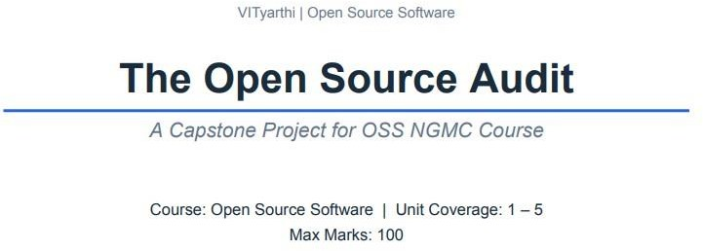

Course: Open Source Software Unit Coverage: 1 – 5

Max Marks: 100

Student Name: Abhishek Mishra
Registration Number: 24BAI10673

Slot: D11
Date of Submission: 31 March 2026

Introduction
Open source software is very important for technology nower days. Python is one of the most used Open-source programming language in today’s world. It is very simple and easy to use and understand , thus it is used by both beginner and professional programmers.

If we talk about present world , Python language plays a important role in various fields such as web development, data science, artificial intelligence, machine learning, and automation. Because of this Python grown a lot and thus become one of most trusted language.

The primary goal of my report is to analyze the language of Python from the point of view of an open-source audit.

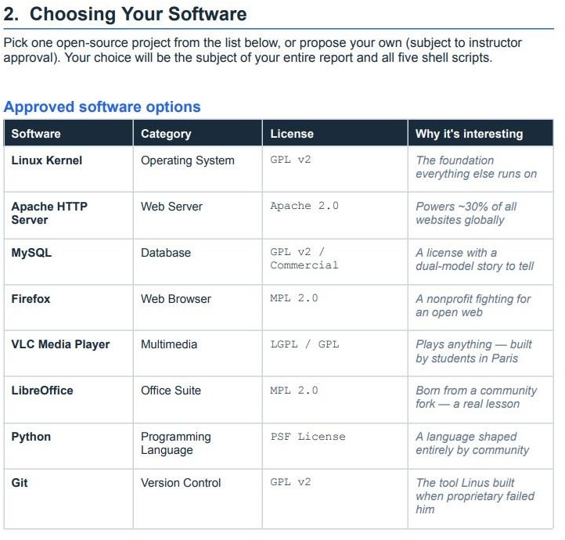

Software Chosen: Python

Why Python Was Developed ?

Python was created because programmers needed a language that was well-balanced to work with. At that time, C was powerful but difficult to use, especially for new programmers, and ABC was easy to use but useless for real programming. This clearly shows that there was a need for something in between – easy to understand but powerful enough to be used for real programming.

Python has fulfilled this role. It has been developed in such a way that the language looks clean and easy to read, almost like real English.
This has made it easy for programmers to think and write solutions without worrying too much about complicated syntax. This has helped programmers to quickly test and later expand their ideas into real programs.

License Analysis

- Python can be used for any purpose, including commercial projects
- It is free to use, modify, and distribute
- You must keep the original copyright notice when redistributing
- You cannot use the Python or PSF name for promotion without permission
- You are not required to open-source your own code
- Modified versions can be kept private
- It is compatible with GPL and can be used with open-source projects

Ethics of Open Source

- Work and Profit

In the case of open-source tools like Python, the developers of the tools are not highly paid or are sometimes not paid at all. But the companies are using these tools and earning huge profits. This has resulted in inequality between the developers and the companies using the tools.
This has led to the burnout of the developers. This situation has raised the ethical question of whether the companies should return to the open-source community.

- Access and Equality

Python is available for all, regardless of their location and financial condition. This has given the opportunity for students to use the tools like the companies. This has removed the financial barrier in the field of software development. This has given the opportunity for the development of the field of open source, which has resulted in equality.

- Responsibility of Use

Since the tools like Python are open-source, anyone can use the tools for any purpose. This has resulted in the development of the tools. This has raised the ethical question of whether the developers of the tools are responsible for the use of the tools.

Linux Footprint

Installation Method
Python 3 was installed on Ubuntu (WSL) using the apt package manager:
sudo apt update
sudo apt install python3 sudo apt install python3-pip
Python is available directly from Ubuntu’s repositories, so no manual compilation is needed. This shows the advantage of open source — easy and ready-to-use installation. Advanced users can still compile Python from source if required.

Key Directories
  - /usr/bin/python3 — main executable
  - /usr/lib/python3.x/ — standard library
  - /usr/lib/python3/dist-packages/ — system packages
  - ~/.local/lib/python3.x/site-packages/ — user-installed packages
  - /usr/share/doc/python3/ — documentation

User and Group (Security)
Python runs as the user who executes it.
  - Normal user :- limited access
  - Root user :- full system access

Service Management
Python itself is not a service, but Python applications can run as services using systemd:
sudo systemctl start myapp sudo systemctl stop myapp sudo systemctl restart myapp sudo systemctl status myapp

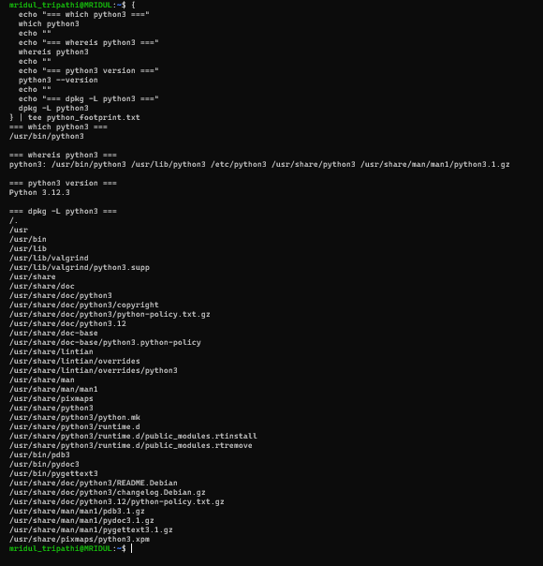

FOSS ECOSYSTEM

  - Python has an important role in the world of open source
  - It both utilizes and supports various open source technologies
  - Python utilizes – OpenSSL ( Security), zlib (Compression) and SQLite.
  - Python enables: Web development, Data Science and Artificial Intelligence
  - It is platform independent and is used in various types of applications

Community contribution:
  - There are many Python developers across the world
  - Contributions through GitHub, discussions, and conferences
  - Because of its flexibility and popularity, Python has an important role in the growth of open source technologies

Comparsion Table

Dimension | Open Source | Proprietary Alternative (MATLAB)
Cost | Completely free of cost | Costs is about 500 to 2000$ per user annually, student discounts available but expensive
Security | Anyone can read Python source code on GitHub and report issues. | Only MathWorks employees can audit and fix security issues
Support and reliability | Community-driven support through Stack Overflow and GitHub issues. | Paid support from MathWorks & more structured but extra cost required
Freedom to modify | Users can modify CPython and customize itself | No modification allowed & users must accept software as MathWorks provides
Community vs  corporate control | No single company controls it | Controlled entirely by MathWorks
Overall verdict | Flexible, transparent, easily accessible and free to use. | Expensive, closed and dependent on one company decisions

Script 1 — System Identity Report
bin/bash
# Script 1: S
#!/ystem Identity Report
# Author: Abhishek Mishra

# --- Variables --- STUDENT_NAME="Abhishek Mishra" SOFTWARE_CHOICE="Python"

# --- System info --- KERNEL=$(uname -r) USER_NAME=$(whoami) UPTIME=$(uptime -p) HOME_DIR=$HOME
DATE=$(date) DISTRO=$(lsb_release -d | cut -f2)
PYTHON_VERSION=$(python3 --version)

# --- Display ---
echo " Open Source Audit — $STUDENT_NAME" echo "Software : $SOFTWARE_CHOICE"
echo "Distribution : $DISTRO" echo "Kernel : $KERNEL" echo "User : $USER_NAME"
echo "Home Directory: $HOME_DIR" echo "Uptime : $UPTIME"
echo "Date : $DATE"
echo "Python Version: $PYTHON_VERSION"
echo "License : PSF License (Python Software Foundation)"

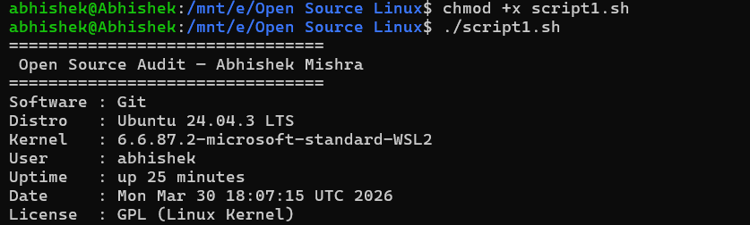

This script tell us about how to install python. How can we use commands and variables to collect data and information by using command such as uname,uptime,etc.
Echo statement help to display all the information in a clean format.

Script 2 — Package Check and Details

#!/bin/bash
# Script 2: Package Check and Details

# Author: Abhishek Mishra | Course: Open Source Software

# --- Variable --- PACKAGE="python3"

echo "================================"
echo " Checking package: $PACKAGE"
echo "================================"

# Check if package is installed
if dpkg -l | grep -q "$PACKAGE"; then echo "$PACKAGE is installed."

echo ""
echo "Package Details:" dpkg -l | grep "$PACKAGE" echo ""
echo "Description:"
apt show "$PACKAGE" | grep Description else
echo "$PACKAGE is NOT installed." fi

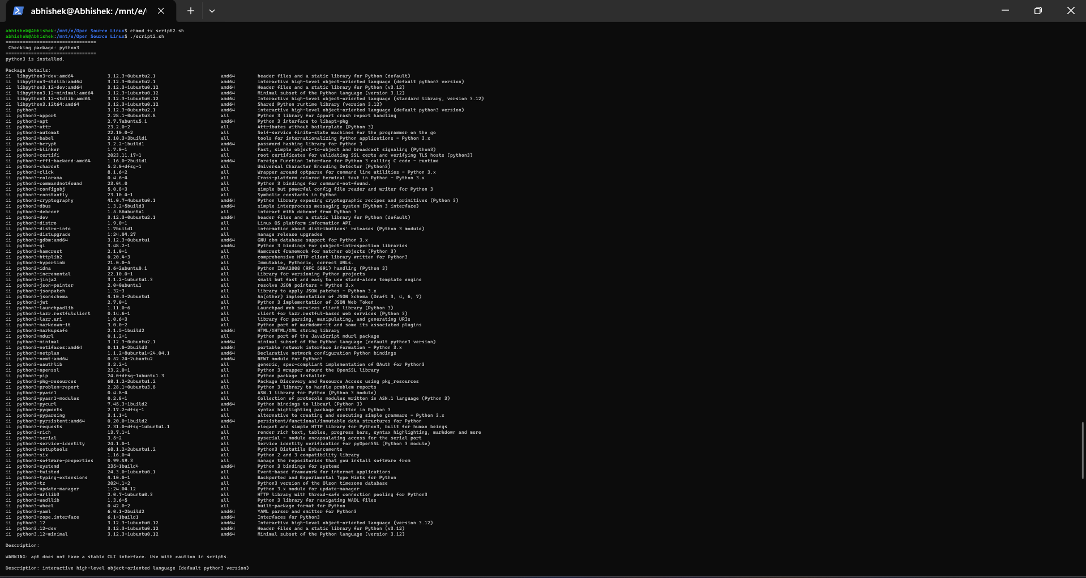

The script tell us whether python is installed or not. It uses the dpkg command to search for Python in list of installed packages. If Python is installed, the script displays its version If the software is not found, it shows a message indicating it is not installed.

Script 3 — Disk and Permission Auditor

#!/bin/bash

# Script 3: Disk and Permission Auditor

# Author: Abhishek Mishra | Course: Open Source Software

echo "================================"

echo " Directory Audit Report"

echo "================================"

# Important directories

DIRS=("/etc" "/var/log" "/home" "/usr/bin" "/tmp")

echo ""

echo "Checking important directories..." echo ""

# Loop through each directory for DIR in "${DIRS[@]}"
do

if [ -d "$DIR" ]; then

PERM=$(ls -ld $DIR | awk '{print $1}') SIZE=$(du -sh $DIR 2>/dev/null | awk '{print $1}')
echo "$DIR => Permissions: $PERM | Size: $SIZE" else
echo "$DIR => Not Found" fi
done echo ""
echo "Checking Python configuration directory..." # Check Python config
if [ -d "$HOME/.config/python" ]; then echo "Python config directory exists."

else

echo "Python config directory not found." Fi
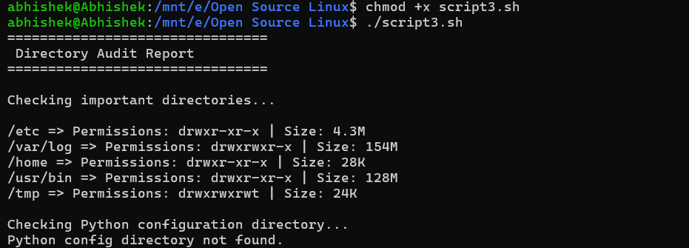

Here script checks some important folders in a Linux system. It checks the directory, /var/log directory,etc and checks whether the folders exist or not. For every directory, it checks the permissions and the size of the directory. It uses the ls command to check the directory permissions and the du command to check the size.

Finally, it checks whether a Python folder exists or not. This script demonstrates how we can use loops, conditions, and some Linux commands to understand the system better.

Script 4 — Log File Analysis

#!/bin/bash

# Script 4: Log File Analysis

# Author: Abhishek Mishra | Course: Open Source Software LOGFILE="/var/log/syslog"
KEYWORD="python"

echo "================================"

echo " Log File Analysis"

echo "================================"

echo "Analyzing log file: $LOGFILE"

echo "Searching for keyword: $KEYWORD" echo ""
# Check if log file exists

if [ -f "$LOGFILE" ]; then

COUNT=$(grep -i "$KEYWORD" "$LOGFILE" | wc -l) echo " "
echo "Keyword '$KEYWORD' found $COUNT times." echo " "
echo ""

echo "Last 5 matching lines:"

grep -i "$KEYWORD" "$LOGFILE" | tail -n else
echo "Log file not found. Trying syslog alternative..." LOGFILE="/var/log/kern.log"
if [ -f "$LOGFILE" ]; then

COUNT=$(grep -i "error" "$LOGFILE" | wc -l) echo "Errors found in kern.log: $COUNT"
grep -i "error" "$LOGFILE" | tail -n 5 else
echo "No log files found." fi
fi
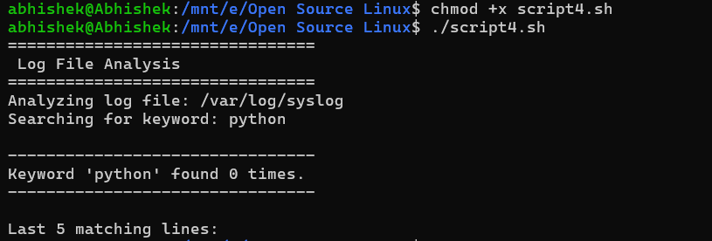

This script is used to check the log files in the system to retrieve any useful information. First, it checks the system log file. Then it searches for the word python. If the file exists, it counts the number of time other word Python in the file and displays last 5 occurrences.

If the file doesn't exist it looks for errors in another file. If there are no files available it displays message.

Script 5 — The Open Source Manifesto Generator
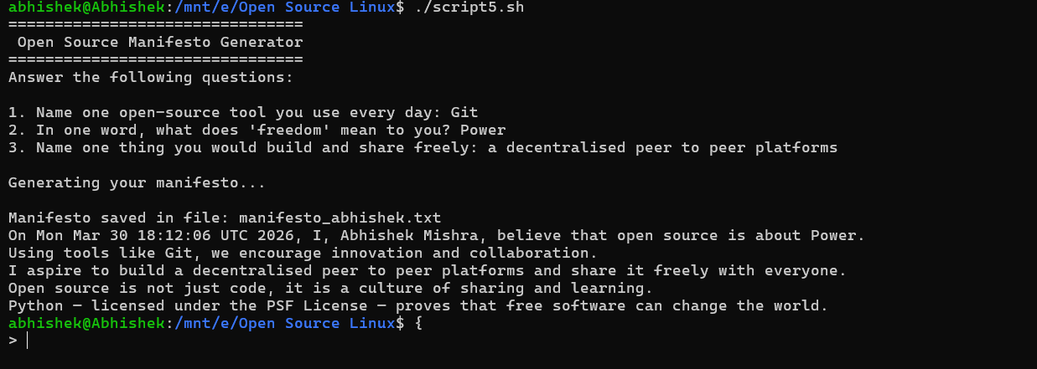

The script is designed to produce a manifesto for open source based on your input. It will first prompt you to input some information. For example, it take input of what kind of open source tool you are using, what freedom means to you, and what you want to create and share.

When we give our information, it will create a new file and write a message based on our input. It will also include a date and name in the message.

Finally, it will save the file and show it on the screen. This script is using your ideas and writing a statement about open source.

Conclusion

Python is a collection of values that include freedom, sharing, and collaboration.Python was initially a small project of Guido van Rossum in 1989, and now it is widely used.The story of Python is a good example of how strong support can build something powerful.

The PSF License allows users to use, modify, and share Python without restrictions.
Python is not limited by restrictions like proprietary software.It is used in many areas including web development, data science, and artificial intelligence.
Python is a good example of how open-source software can change the world.

